Garden pic

Rene Asmussen. 01/23/2022 from <https://www.pexels.com/photo/gazebo-against-trees-334978/>

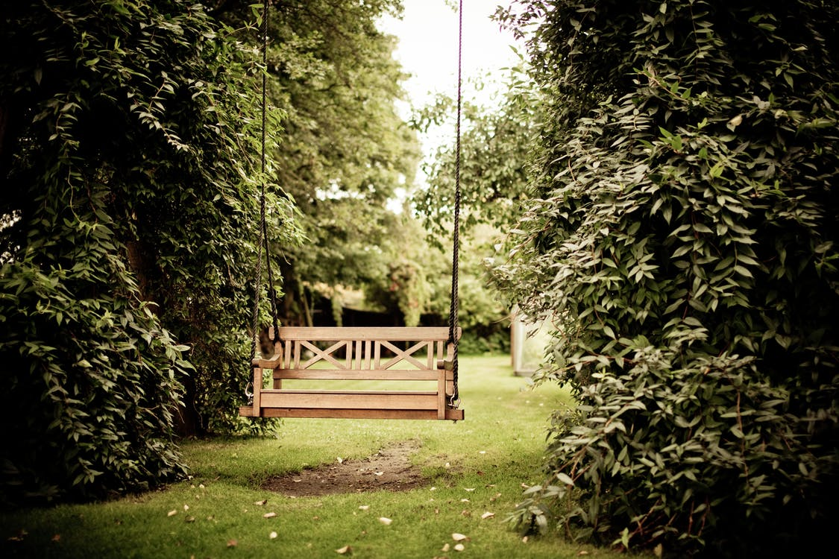

Photoshop picture

